**How to sign into Skype for Business (Previously Microsoft Lync)**

Open **Skype for Business**

*(Can be found by pressing the Windows Key and then typing ‘Skype’)*

Sign in with your **Department Credentials**

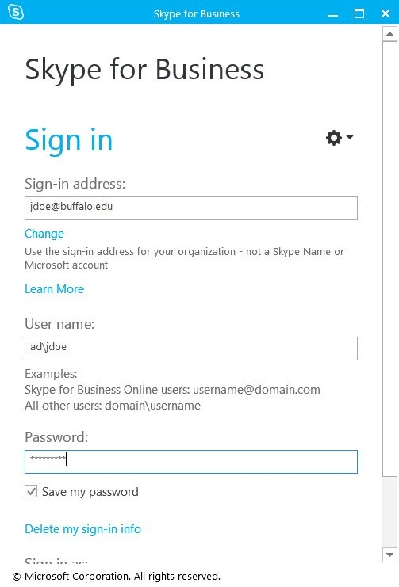

Department Credentials Include:

• **E-Mail Address**

eg. buckland.shaun.c@edumail.vic.gov.au

• **Username**

eg. edu001\ST01476

*(Yours will be your TO Number with*    
 *edu001\ on the end)*

**• Password**

*(This will be your eduMail password)*